Python (High School)
Python Beginners Tutorial | Getting Started | Basic Programming 1 - Bing video
Python Beginners Tutorial | If Else Loops| Basic Programming 2 - YouTube
Python Beginners Tutorial | Python Functions | Basic Programming 3 - YouTube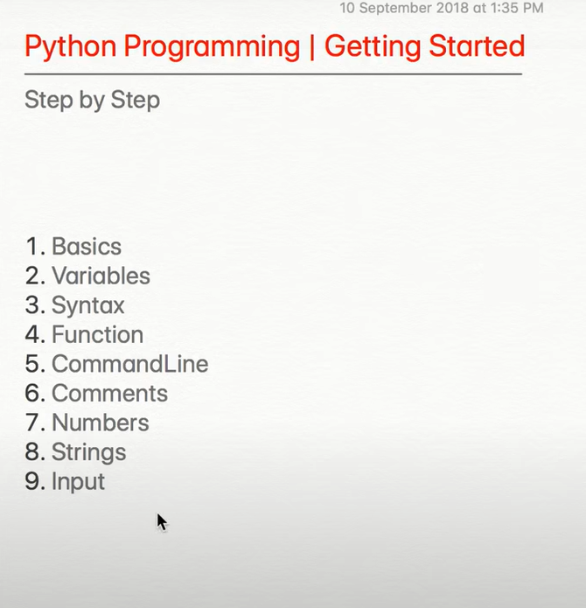
9 videos in total to series

Python - Basic Operators (tutorialspoint.com)
Math operators + Basics

Input and Output in Python - GeeksforGeeks
Message, Integer + more

Conditionals and Flow Control (utexas.edu)
if , elif, else statements and has a chapter (1) that has an intro to python
Also Scientific Python and Numerical Linear Algebra chapter

Python Loops (w3schools.in)
For loop, while loop, and nested loop graphical representation and example

Python Boolean Logic: Not As Scary As It Sounds • The Hello World Program
Boolean

Learn Python Core | Sololearn
Given in PowerPoint slide
Basics + more

Python Tutorial (w3schools.com)
Given in PowerPoint slide
Run code

Learn Python - Free Interactive Python Tutorial
Given in PowerPoint Slide
Learn Basics
Data Science Tutorials
Advanced Tutorials

