Catapults
Event Date: September 27- Oct 15
Event Location: At your school site

Objective: Create a device to launch a starburst at a target on the ground located seven (7) feet away from the marked launch point on a standard 6-foot (6 ft long by 29 inches high) table to win a prize. There will be four prizes based on the initial landing spot of the starburst.

Participation: The prize competition will take place at the University of the Pacific in an outdoor area. The exact location will be disclosed closer to the date of the competition, as CDC guidelines are subject to change (make sure to keep an eye out for our text messages and check our www.pacific-mesa.com website often for updates). MESA Advisors at individual school sites can decide on the in-class grading structure for the project. Participation at the Pacific MESA Center level is optional, but recommended. It will be fun!

Materials:
- Students may use their own materials from home (recycled materials, purchased materials, etc.) or those provided in class.
  - You have free range on what materials you use, but the device must follow the guidelines that will be listed below.
  - Materials supplied in class are enough for 12 teams of 2-3 students. Each team should get the below materials.
    - 1 small paper cup
    - 20 popsicle sticks
    - 2 wooden pencils
    - 25 rubber bands
    - 5 paper clips
    - 1 plastic spoon
    - 6 ft of string
    - 1 starburst
    - 1 – 4oz bottle of Elmer’s Glue
  - Advisors – if your box is short any of these items, please let Rose or Elana know

Guidelines:
- The device must not contain any hazardous materials.
- The device must be able to sit flat on a standard 6-foot long folding table.
- The device must be able to launch a standard 2 3/8 inch x 7/8 inch x 7/16 inch pink starburst that will be included in the kits, but can also be provided at the competition if needed.
- The device can be held down with one hand while the other hand operates it.

Launching and Target
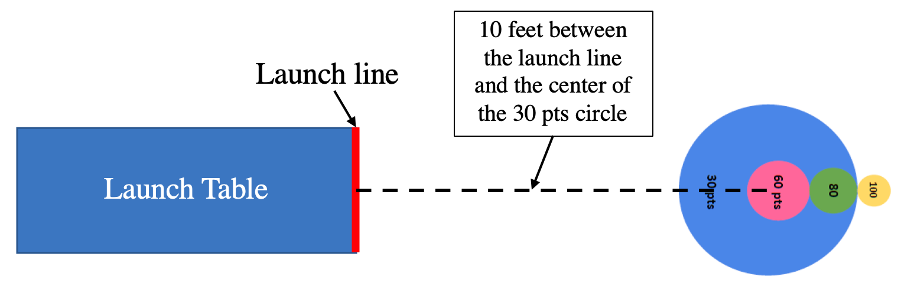
7
- You will set your device on the table with the front of it sitting on or behind the launch line which will be marked with blue painter’s tape.
- You will have up to one minute to prepare for your launch.
- Once ready, or at the end of one minute, the judges will give you a 5 second countdown and you will launch once they say “GO”.
- The first touch point of the starburst will be what will be counted as your landing spot.
- You will have three launches in a row and can keep your highest score
- The higher the points of where you landed, the better your prize will be!

Examples of catapults:

