Stick Together
Spring Challenge 2023, May 10th 2023
LEVEL: Middle School
DIVISION(S): Grade 6th and Grades 7th/8th
COMPOSITION OF TEAM: 2-3 of Students per team
OVERVIEW: | Students will use math and science to implement engineering concepts in the design and construction of a model bridge from their own plans that will carry a maximum load while using as few craft sticks as possible; stressing neatness, craftsmanship, and creativity. Bridges must be complete by May 10th and turned in to your MESA advisor. MESA advisors will bring bridges to Pacific to be tested by the Pacific MESA Center.
MATERIALS: | - Only solid untreated (no manufactured notches or holes), natural wood craftsticks (e.g., popsicle sticks) with the following approximate dimensions may be used:  - Length= 4 ½ inches (11.4cm)  - Width = 3/8 inches (0.95cm)  - Thickness = 1/16 inches (0.2cm)  - Maximum number of sticks allowed, including partial sticks, is 200. Each piece of stick, regardless of size, will be counted as one structural member.  - Only water-soluble Elmer’s-type white glue must be used.
GENERAL RULES:
- Stick Together structures should be labeled with team members’ name, grade level, school, and MESA Center. There will be a 10% penalty in the strength to weight score for improper labeling.
- No kits are allowed.
- A maximum of 50% of a craft stick’s total wide/flat surface may be glued. Both sides of each stick can be considered in the 50% calculation (e.g., 100% of side 1 and 0% of side 2; 75% of side 1 and 25% of side 2). NOTE: if a whole craft stick is divided into smaller pieces, then this rule also applies to those members.
- Glue (i.e., water soluble Elmer’s type white glue) must only be used at joints and must not be used on the surface of the roadway.
- The bridge MUST meet the following dimension restrictions:
  - Maximum horizontal length = 17 inches (43.2 cm)
  - Maximum width = 5 inches (12.7 cm)
  - Maximum height above the top of the roadway = 7 inches (17.78 cm)
  - Maximum depth below the top of the roadway = 3.5 inches (8.89 cm)
  - Minimum horizontal length = 15 inches (38.1 cm)
  - Minimum width at every point = 4 inches (10.16 cm)
  - Minimum width of open roadway across entire bridge length = 3.5 inches (8.89 cm)
- The bridge must have a clear and unobstructed roadway at least 3 ½ inches wide, running the full length of the bridge, as if automobile traffic were going to cross it. The roadway shall be considered a roadway if a toy model car or truck freely rolls from one end to the other. The toy car/truck can be provided by the entrant. If a car is not provided by the entrant, a standard “Hot Wheels” or “Matchbox” car will be used.
- The bridge may not have a roof, covering or any other object that will interfere with the 3½ x 3½ inch test plate that is placed directly on roadway at mid span to apply the force for load bearing capacity.
- I-beams are illegal.
- T-sections and longitudinal lamination may be used on the roadway only.
- The bridge must rest on the tester support blocks in a stable manner (i.e., bridge substructure may NOT interfere with testing apparatus).
- Project must be the original work of student(s). Judges may ask questions to confirm provenance.
- Please remember that the purpose of this contest is to use creativity to build the best structure within the framework of the rules.
- Digital media (e.g., photos, video recordings, etc.) will not be accepted for arbitration purposes.

JUDGING:
- The bridge is examined and measured by the judges to check whether it conforms to contest rules and specifications.
- Any bridge that does not meet the requirements will be disqualified.
- The bridge is weighed, and its weight recorded.
- The bridges are judged for neatness, craftsmanship, and creativity by a team selected by the Host Center prior to testing.
- The bridge will be supported by two wide blocks (each >1 inch) 14 inches apart (see Testing Setup & Apparatus).
- A 3½ x 3½ inch test plate is screwed onto the bridge at mid span so that it rests on the roadway. A hole must be present in the roadway mid-way to attach the test plate. The hole can be created with a missing stick or drilled.
- The test plate is loaded until a point of maximum load is reached as determined by judges. The maximum load recorded by the load testing machine will be used as the load capacity of the bridge, regardless of when failure begins.
- Individuals’ bridges are not limited in the number of categories they may win.
- Disqualified bridges are not eligible for awards in any category; however, they may be tested, time permitting.
- Strength-to-Weight Ratio: Determined by dividing maximum load at failure by weight of bridge. Bridge with greatest load bearing capacity compared to its weight wins.

Example: Maximum load = 220.0 pounds
Bridge weight = 50.0 grams
Ratio = [220 pounds x 454g/pound)/50g] = 1997.6
AWARDS:
  - Awards will be given per division: Grade 6th and Grades 7th/8th.
  - Medals will be awarded for 1st, 2nd, and 3rd place based on the best Strength-to-Weight Ratio.
  - Medals will be awarded at the MESA Awards Banquet on May 18th. Winning teams may invite their families to join them.

ATTACHMENTS/APPENDIX:
  - A – Testing Setup & Apparatus
  - B – Definitions and Samples
  - C – Specification Checklist

A – TESTING SETUP & APPARATUS

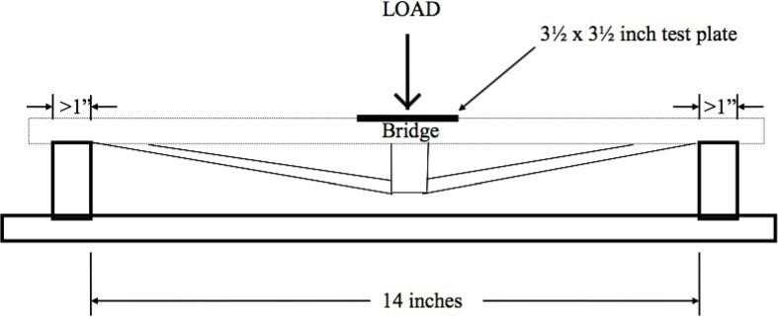

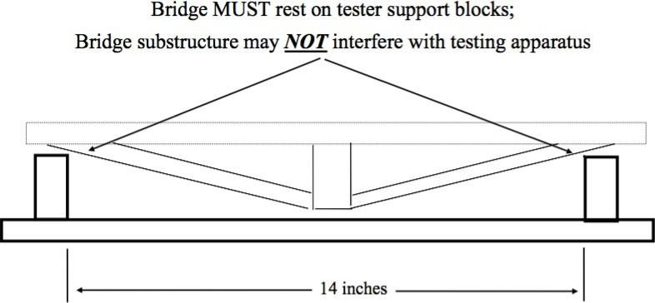

B – DEFINITIONS AND SAMPLES

Per General Rule #3

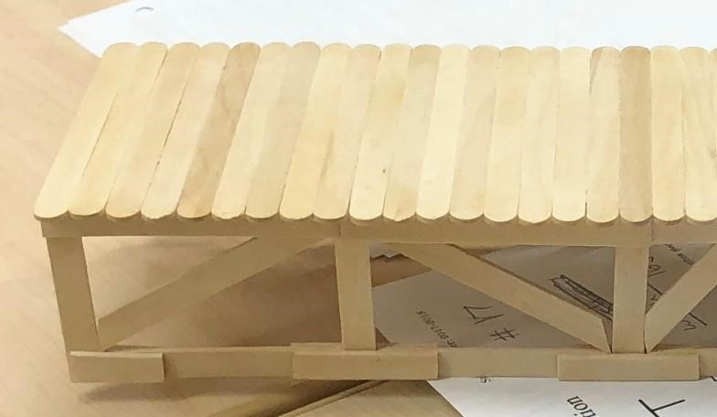
OK

Top: Because the member that is covering 50% of its area are not in contact with any other member, it is considered legal.

Bottom: The members are already 50% in contact with the roadway and are also in contact with other members. Therefore, they are joining with member at more than 50% of its area.
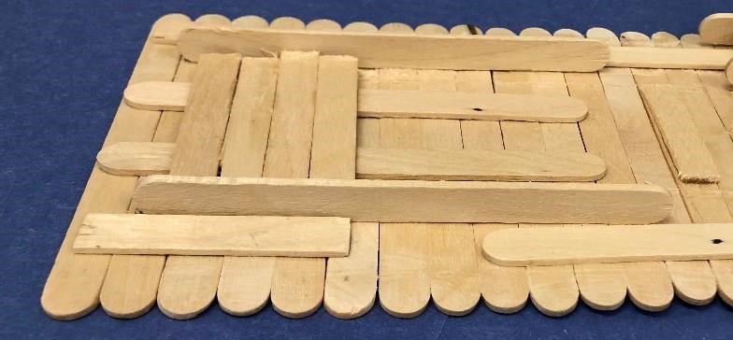

NOT
OK

Per General Rules #4 & 5
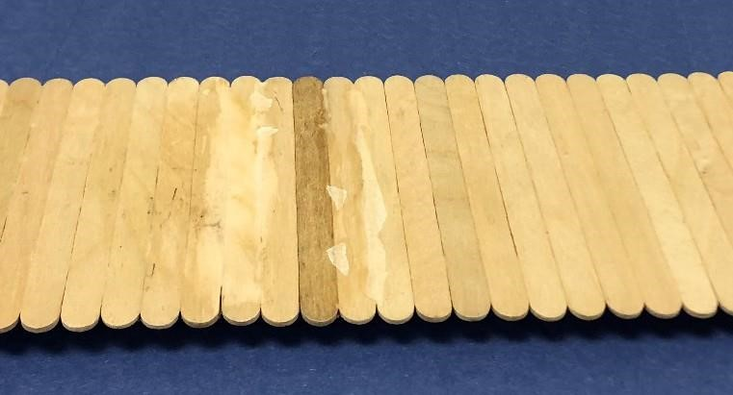

NOT
OK

Glue is visible on areas other than the joints and the remains of wax paper left on the roadway are considered coating. Easy way to fix this is to sand off the excess glue or wax paper.

Per General Rules #7, 8 & 9
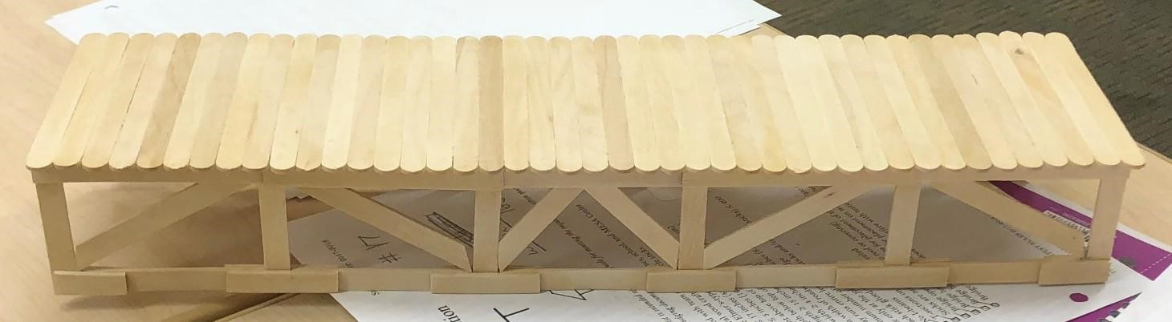

OK

The bridge is open and allows testing apparatus to be placed, the roadway created is clear, gapless and unobstructed, and lastly it does not have a roof.

Per Rule #10
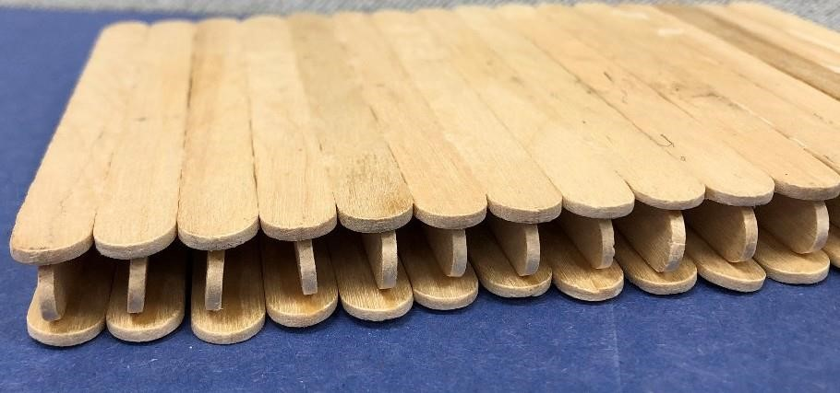

NOT
OK

I-Beams are illegal in the bridge’s structure.

Per Rule #11
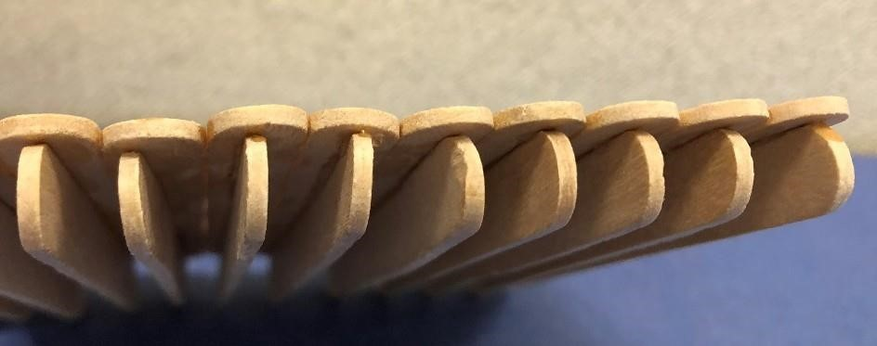

OK

Top: T- Beam are only allowed to be elements of the roadway.
Bottom: Longitudinal lamination may be used on the roadway only.
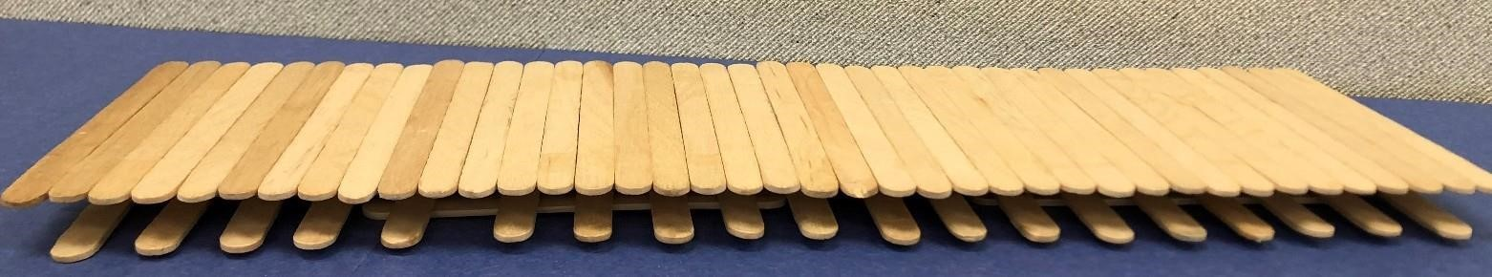

OK

– SPECIFICATION CHECKLIST
*Note: As the name above implies, this list is intended simply as a guide for meeting the required competition specs. It should not be treated as an official judging document.

⇨ Bridge is properly labeled with team members names, school, and MESA Center
⇨ Material is solid, natural wood craft sticks (popsicle sticks)
⇨ Glue is water soluble Elmer’s-type white glue
⇨ Maximum length ≤ 17 inches (43.2 cm)
⇨ Maximum width ≤ 5 inches (12.7 cm)
⇨ Maximum height above top of roadway ≤ 7 inches (17.78 cm)
⇨ Maximum depth below top of roadway ≤ 3.5 inches (8.89 cm)
⇨ Minimum length ≥ 15 inches (38.1 cm)
⇨ Minimum width ≥ 4 inches (10.16 cm)
⇨ Minimum width of roadway ≥ 3.5 inches (8.89 cm)
⇨ Roadway runs entire length of bridge
⇨ Maximum number of members (sticks and/or partial sticks) ≤ 200
⇨ Glue only at the joints
⇨ Each stick glued ≤ 50%
⇨ No I-beams
⇨ T-sections on roadway only
⇨ Sticks are not painted or treated
⇨ Bridge open at the top (no roof or covering)
⇨ Bridge has open 3½ inch area for placement of the test plate on roadway
⇨ Bridge has supports suitable for placement on testing fixture
⇨ Bridge substructure does not interfere with testing fixture

