Civil Structures
Spring Challenge 2023, May 10th 2023
LEVEL: High School
DIVISION(S): Grades 9th/10th and Grades 11th/12th
COMPOSITION OF TEAM: 2-3 of Students per team
OVERVIEW: | Students will design and construct a model balsawood bridge from their own plans that will carry a maximum load while using as little wood as possible, stressing neatness, craftsmanship, and creativity. Bridges must be complete by May 10th and turned in to your MESA advisor. MESA advisors will bring bridges to Pacific to be tested by the Pacific MESA Center.
MATERIALS: | - ¼” x ¼” square balsawood (ten 3 ft lengths usually sufficient)  - Only water-soluble Elmer’s-type white glue.

GENERAL RULES:
1) Civil Structure should be labeled with team members’ name, grade level, school, and MESA Center. There will be a 10% penalty in the strength to weight score for failing to properly label.
2) No kits are allowed.
- Joints must be at or within ¼” of the end of at least one of the sticks (members). No part of a stick may be glued to another stick except at the joints of sticks (i.e., gluing is very limited). See Appendix
C, “Clarification of Gluing.”
- No glue may extend beyond 3 mm of any joint.
- The bridge MUST meet the following dimension restrictions:
  - Maximum length = 40 cm
  - Maximum width = 10 cm
  - Maximum height = 21 cm
  - Minimum clearance = 10 cm
  - Minimum span = 25 cm
  - Maximum Bridge Weight = 95 grams
- Members joined at an angle must be at an angle of 30 degrees or more.
- Members may be carved, notched, or cut anywhere along their length.
- Pins and/or gussets are not allowed.
- No material (e.g., paint, varnish, hairspray, etc.) may be applied to the bridge. Ink or pencil is allowed to identify bridge builders, grade level, school, and center.
- Maximum allowable weight of completed structure is 95 grams.
- Top of bridge must support a 10 cm x 10 cm plate which will bear the load for testing.
- Bridge must have supports at least 25 cm apart and must measure at least 10 cm above a flat surface (e.g., an imaginary “river”) at least one point (may be more than one point) between the supports. 13) Project must be the original work of student(s). Judges may ask questions to confirm provenance.
- Please remember that the purpose of this contest is to use creativity to build the best structure within the framework of the rules. The purpose is not to break the rules and see if you can get away with it.
- Digital media (e.g., photos, video recordings, etc.) will not be accepted for arbitration purposes.

JUDGING:
- Prior to load testing, the bridge receives a specification check to determine whether it conforms to the weight, dimension, and construction rules.
- The bridge is weighed and its weight recorded.
- Bridges are judged for neatness, craftsmanship, and creativity by a team selected by Host Center prior to testing.
- The bridge will be tested for load bearing capacity using the set-up shown in Testing Setup & Apparatus. The maximum load recorded by the load testing machine will be used as the load capacity of the bridge, regardless of when failure begins.
- Disqualified bridges are not eligible for awards in any category. However, they may be tested in private, time permitting.
- Strength-to-Weight Ratio: Determined by dividing maximum load at failure by weight of bridge. Bridge with greatest load bearing capacity compared to its weight wins.

Example: Maximum load = 120.0 pounds
Bridge weight = 20.0 grams
Ratio = [120 pounds x 454g/pound) / 20g] = 2724.0

- Creativity & Engineering Design: Finest workmanship, including neatness and innovation of design.

AWARDS:
  - Awards will be given per division: Grades 9th/10th and Grades 11th/12th.
  - Medals will be awarded for 1st, 2nd, and 3rd place based on the best Strength-to-Weight Ratio.
  - Medals will be awarded at the MESA Awards Banquet on May 18th. Winning teams may invite their families to join them.

ATTACHMENTS/APPENDIX:
  - A - Sample Joints
  - B - Testing Setup & Apparatus
  - C - Clarification of Gluing
  - D - Specification Checklist

    - – SAMPLE JOINTS

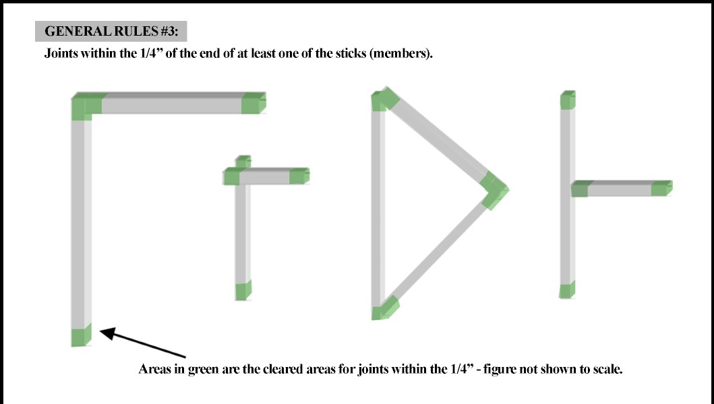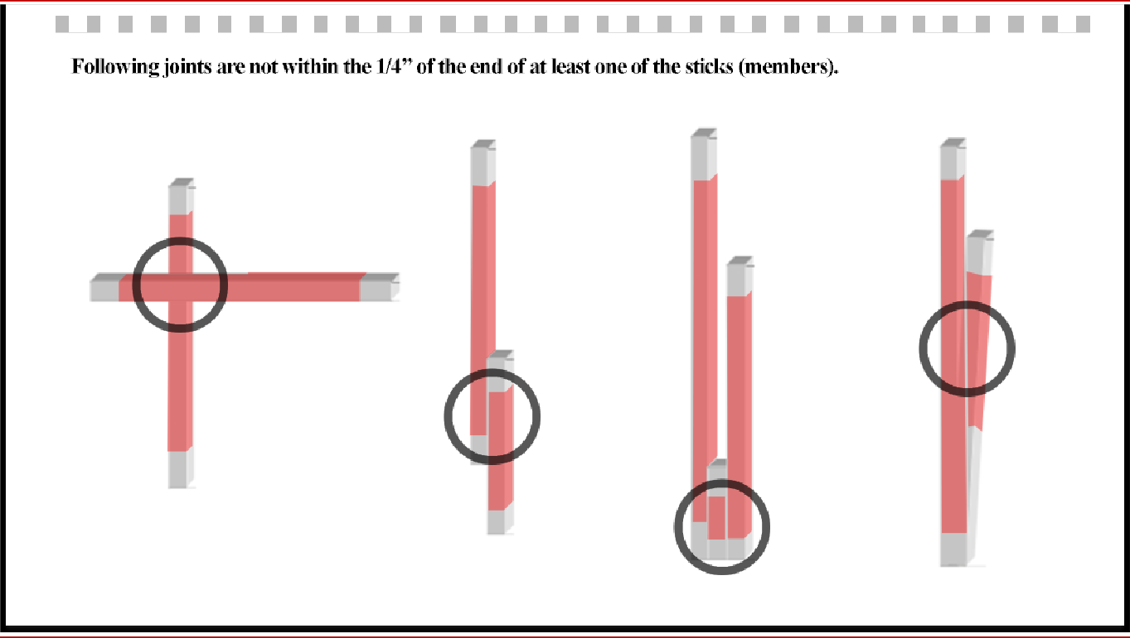

    - – TESTING SETUP & APPARATUS

- Figure 1a: Overall Dimension Test: The bridge must fit inside a box with the following dimensions to be considered legal; bridge must also pass the 10 cm clearance test.

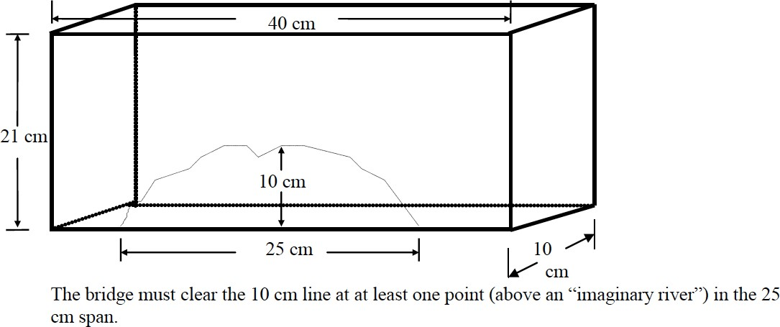

- Figure 1b: The bridge will be supported on both of the blocks as shown:
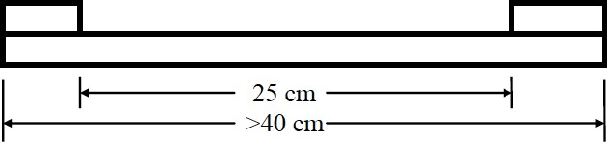

- Figure 1c: Span clarification between bridge supports.
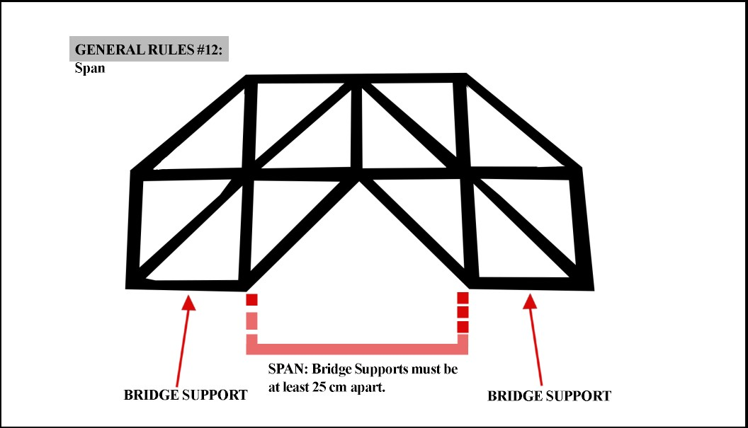

- Figure 1d: Imaginary River and clearing the 10 cm line.
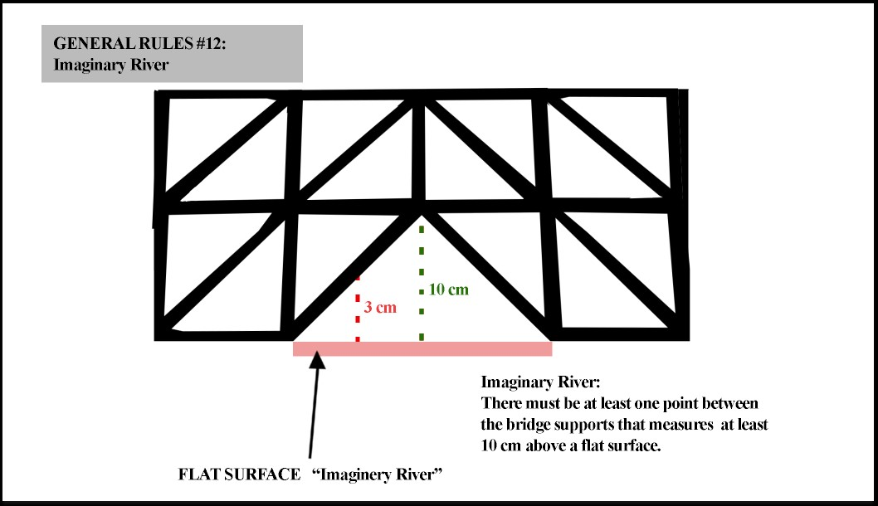

- Figure 2: The bridge is tested for strength by applying weight (force) to a 10 cm square plate placed on top of the bridge. The bridge is tested for strength while sitting on the blocks. Additionally, note dimension details in the figure below.
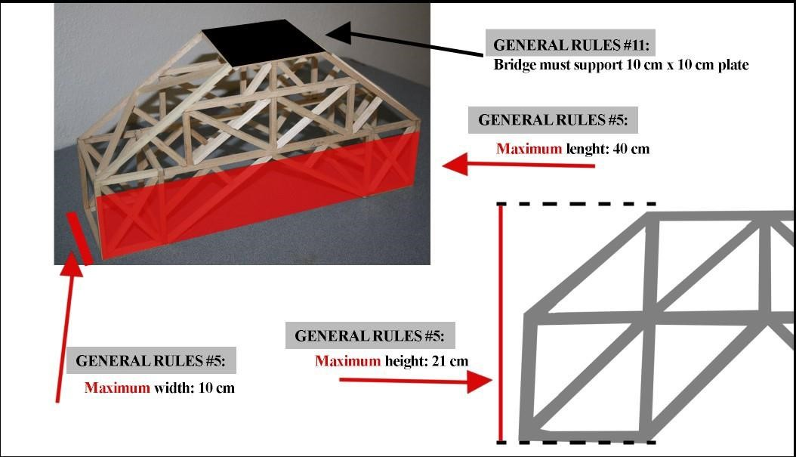

- Figure 3: Members joined at an angle must be at an angle of 30 degrees or more.

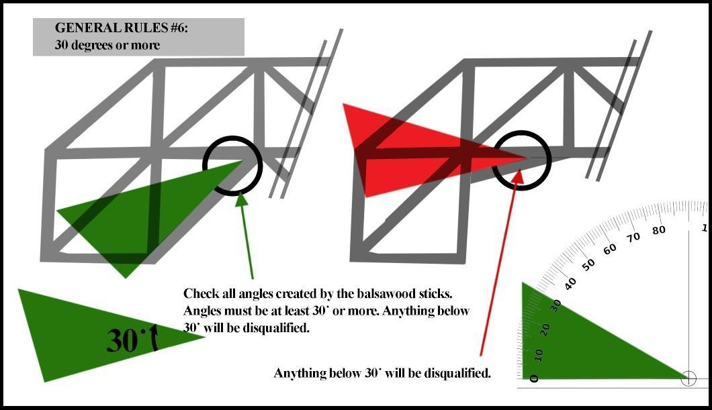

C – CLARIFICATION OF GLUING

- The spirit of the gluing rule is to allow bridges made of balsa ONE LAYER thick. Since the balsa may need to be overlapped at the joints, the bridge may need to be more than one layer thick at the joints.
- Rule for Construction #1 states: “Joints must be at or within ¼” of the end of at least one of the sticks (members). No part of a stick may be glued to another stick except at the joints of sticks. (i.e., gluing is very limited). (See ATTACHMENTS/APPENDIX – Sample Joints)
- Since dry glue is nearly invisible and it is impossible to tell what part of overlapping members is glued and what part is not, judges must assume that the entire length of overlapping members is glued. Therefore, no two members anywhere on the bridge may overlap by more than ¼”.
- ¼” long pieces of balsa may be used as “spacers.” A spacer is defined as a piece whose sole role is to separate structural members (such as at the corners of the bridge).
- Wholly glued pieces which appear to strengthen, reinforce, serve a purpose other than separating, or are placed too closely together will be considered lamination, not spacers.
- Determination of what is a spacer and what is excessive gluing will be left solely to the judges. Since this may be a “gray area,” with disqualification as a possible result, students are encouraged to avoid the use of spacers.
- Please remember that the purpose of this contest is to use creativity to build the best structure within the framework of the rules.

D – SPECIFICATION CHECKLIST
*Note: As the name above implies, this list is intended simply as a guide for meeting the required competition specs. It should not be treated as an official judging document.

⇨ Bridge is properly labeled with team members names, school, and MESA Center
⇨ Material is ¼” x ¼” balsawood
⇨ Glue is water soluble Elmer’s-type white glue
⇨ Maximum length ≤ 40 cm q Maximum width ≤ 10 cm q Maximum height≤ 21 cm
⇨ Minimum clearance above “river” ≥ 10 cm
⇨ Minimum Span ≥ 25 cm
⇨ Maximum Bridge weight ≤ 95 grams
⇨ All joints are at or within ¼” of end of one member
⇨ No glue beyond 3mm from any joint
⇨ No excessive gluing (i.e. members are glued only at the joints)
⇨ All members joined at an angle ≥ 30°
⇨ No pins or gussets used
⇨ Balsawood is not painted or treated
⇨ Top center of Bridge has 10 cm x 10 cm area for placement of the test plate ⇨ Bridge has supports suitable for placement on testing fixture

